Java 3 Project

30003389 – Kyer Potts

Table of Contents

Table of Contents i

Software Management Tools 1

Software Development Lifecycle 1

Project Management Software 1

Source Control 1

Collaboration Tool 1

Project Plan 2

Source Control 3

Collaboration Tool 4

Target Machine Specification 5

System Requirements 5

Operating System 5

Platform 5

Required disk space 5

CPU 5

Memory 5

Peripherals 5

Current System 5

Disk Space 5

CPU 5

Memory 5

Peripherals 5

Installation Method 6

Java Executable File 6

XAMPP 6

Installation Package Creation 7

Installation Demonstration 9

Uninstallation 10

Database Deployment 11

Application Configuration 12

# Software Management Tools

### Software Development Lifecycle

This project will be implementing the Waterfall Model SDLC to manage and complete this project in a 21-day (3 week) development timeframe. This development model was chosen for it’s ease of use and manageability due to the scale of the application. As this is a small-scale application with well-defined requirements, many of the risks associated with the Waterfall methodology are alleviated, making it the best possible choice for the development of this project.

### Project Management Software

I will be using Project Libre as my project management tool. It is an easy to use free open source management tool with robust features that allow for fine tuning of planning details and layouts. It is also compatible with many other project management applications, including Microsoft Project. Project Libre has an inbuilt Gantt chart that automatically populates based upon tasks and timeframes entered in the table.

### Source Control

GitHub will the functional source control for the development of this software. GitHub allows for easy source control through the implementation of branches, pull requests and merge requests. These features ensure that all team members will be able to work on separate pieces of the project without disrupting workflow or jeopardising each other’s work.

### Collaboration Tool

Trello will be the collaboration tool used for this project. It is free and accessible through any internet browser, as well has having a clean, easy to manage interface.

# Project Plan



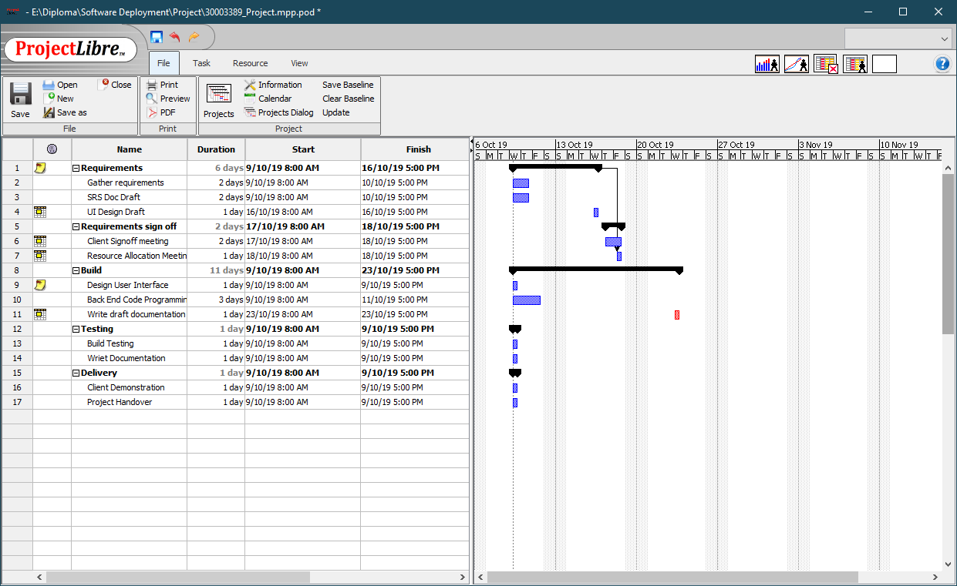

# Source Control

<https://github.com/kyerpotts/DVD_Search>

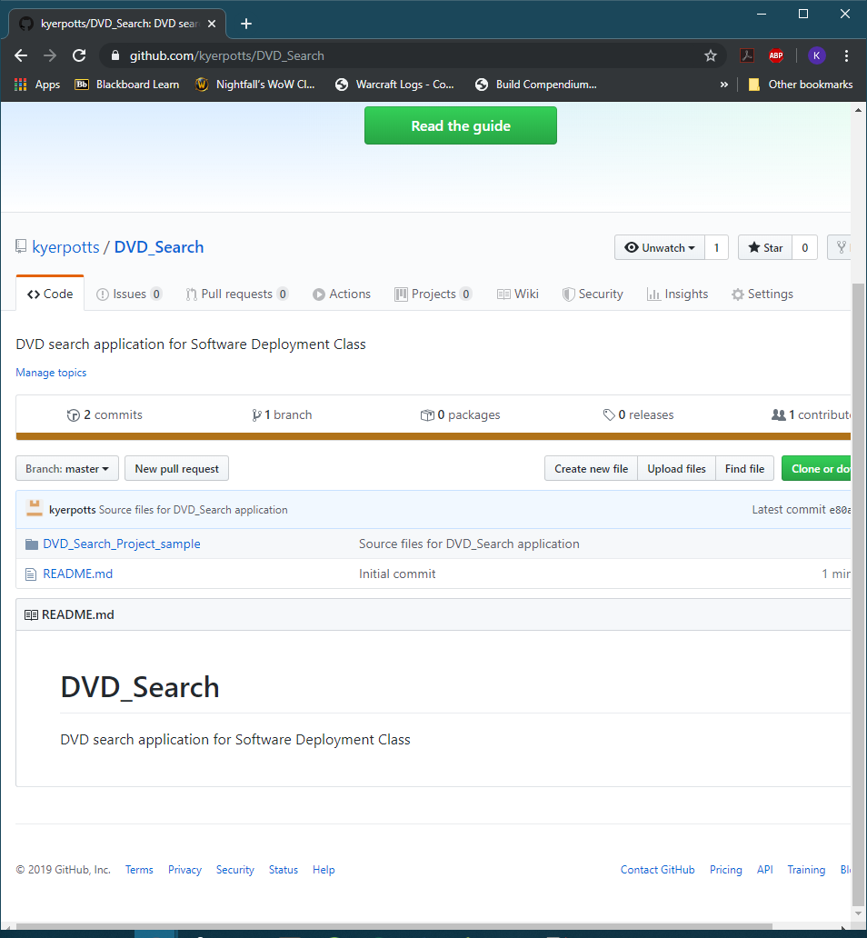

# Collaboration Tool

<https://trello.com/b/pb0DJvgK/dvdsearch-project>

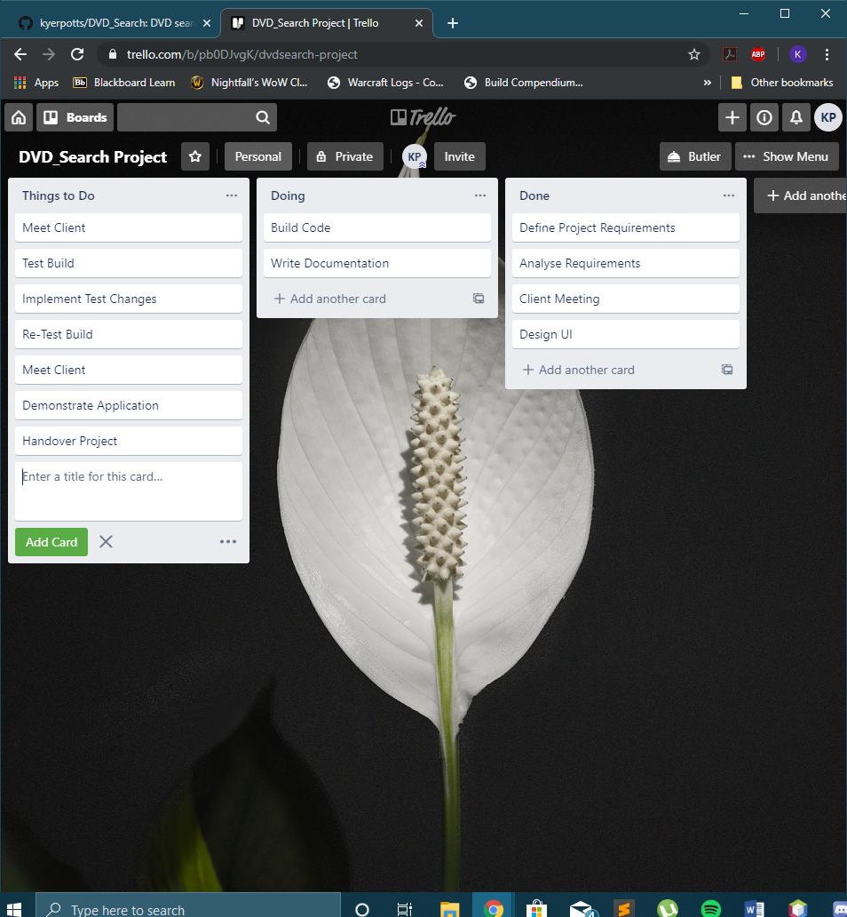

# Target Machine Specification

## System Requirements

### Operating System

* Windows 2008, 2012, Vista, 7, 8 (Important: XP or 2003 not supported)
* Most all distributions of Linux are supported, including Debian, RedHat, CentOS, Ubuntu, Fedora, Gentoo, Arch, SUSE.
* Mac OS X 10.6 or later.

### Platform

Java is the required platform to install and run this program

### Required disk space

10GB

### CPU

Pentium 2266 MHz process minimum required to run Java

### Memory

2GB minimum RAM

### Peripherals

Monitor, keyboard and mouse

## Current System

### Disk Space

476gb total capacity, 37.3gb free space

### CPU

Core i7-8750H @ 2.2GHz

### Memory

16GB RAM

### Peripherals

Monitor, keyboard and mouse

# Installation Method

### Java Executable File

* Download or copy the Java executable file onto your system
* Run the executable JAR file to run the program

### XAMPP

* Download the executable file for XAMPP found here <https://www.apachefriends.org/download.html>
* Run the file and follow the installation steps
* Open the xampp-control.exe file in the XAMPP installation folder
* Start the Apache Module
* Start the MySQL Module
* Import the dvd.sql file into the SQL location

# Installation Package Creation

The installation package was created by generating a JAR executable file from the project class files. The method to achieve this is followed below:

* Determine the location of the source files
  + 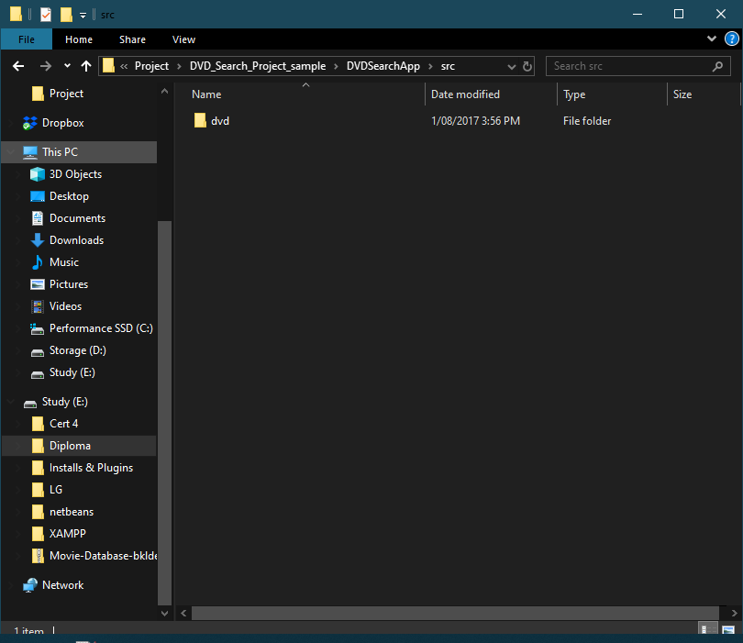
* Create a manifest file which includes all appropriate information
  + 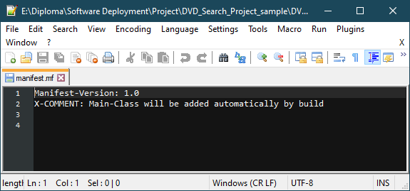
* Create a batch file with the following information
  + 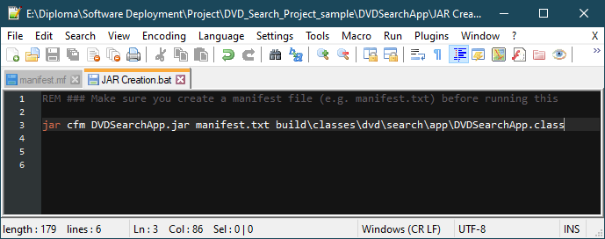
* Run the executable file that was created by the batch file
  + 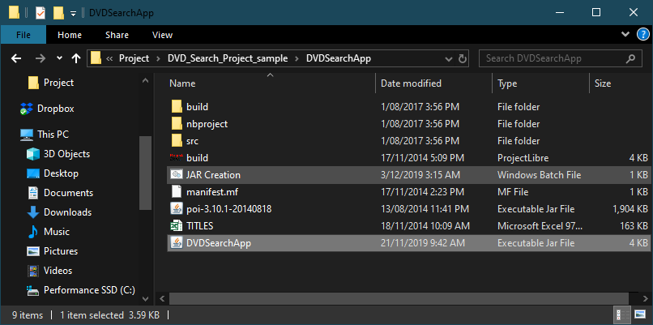
  + 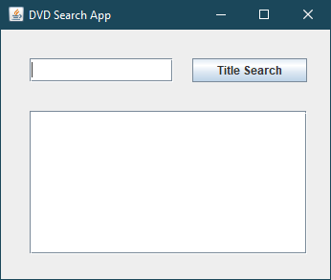

# Installation Demonstration

* To run the newly created JAR file, first the Java Runtime environment will need to be installed
  + 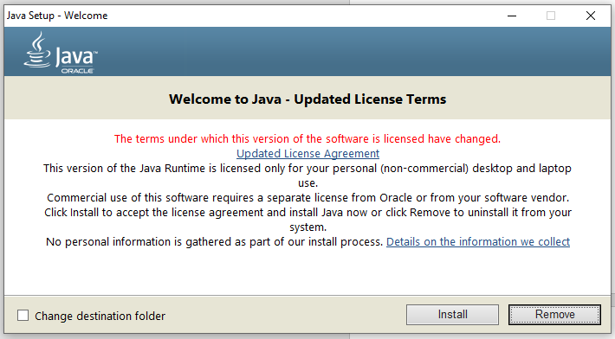
* The JAR file must then be copied to your system
  + 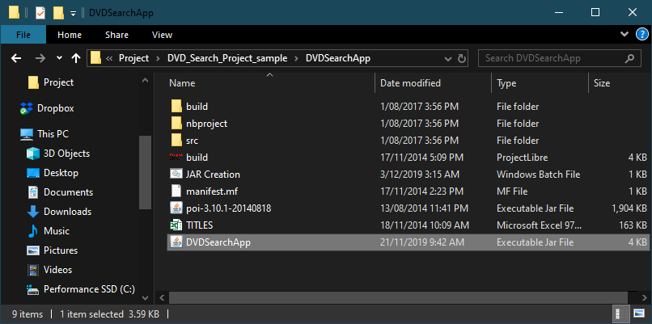
* The jar file can then be executed and run
  + 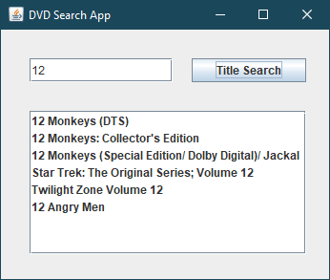

# Uninstallation

* To uninstall the application from your system, simply right click the executable JAR file and select Delete
  + 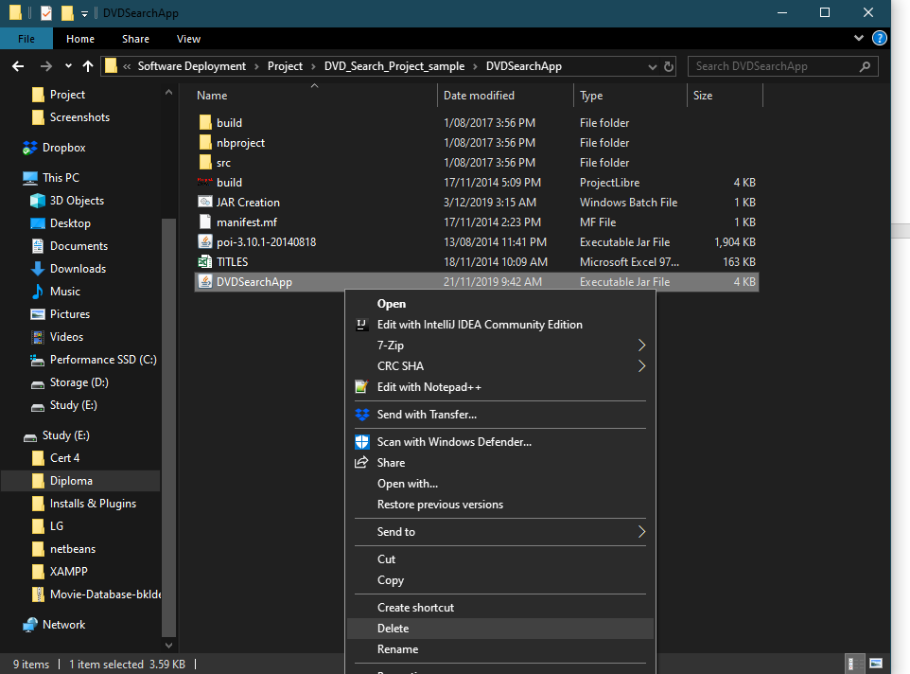

# Database Deployment

To deploy the database, first ensure XAMPP is installed and the MySQL server is running

* Open MySQL and import the data from “dvd.sql”
* This will create the database and the tables
* The CSV data will also be imported into the database
* The JDBC Connector will also need to be downloaded and installed into the application
  + The JDBC connector can be found here <https://dev.mysql.com/downloads/connector/j/5.1.html>
* Add the connector to the Libraries folder within the project
  + 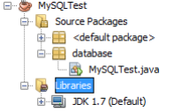
  + 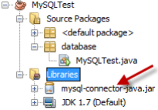
* The following connection string will also need to be added to connect to the database

*String url = "jdbc:mysql://localhost:3306/dvd_search"; //jdbc, database name and port*

*String user = "root"; //username*

*String password = "root"; //password*

*con = DriverManager.getConnection(url, user, password); // connection string*

# Application Configuration

No configuration files have been used for this application.

System Administrator permissions are required to install Java and XAMPP

Java may block the application for the following reasons:

* The application is unsigned.
* The user is trying to run a self-signed application from an untrusted authority.
* Application’s jar file is missing a permission attribute.